Project: Moffat Bay
Course: CSD 460
Description: Registration Page testing
Date: 09/05/2026
To complete the test case plan, fill out the information for Project, Course, Description and Date in the header below.
.
TABLE OF CONTENTS
<DESCRIPTION> 2
<DESCRIPTION> 2
<DESCRIPTION> 3

For each test, the developer should: provide a test description, a test objective, the developer name and date tested. For each step, fill out the actions to be taken and describe the expected results, and indicate yes or no for each step depending upon the result. The peer tester should provide their name, date tested, indicate yes or no for each step depending upon the result, and a screenshot (thumbnail) of the result.

Test 1 | Make sure Registration page loads with the form
 | Test Objective: | Developer: Matthew Rozendaal  Date tested: 2026/09/05 | Developer: Matthew Rozendaal  Date tested: 2026/09/05
Step | Action | Expected results: | Developer pass/fail | Tester pass/fail  + Screenshot
1 | Go to Moffat-Bay.index html | 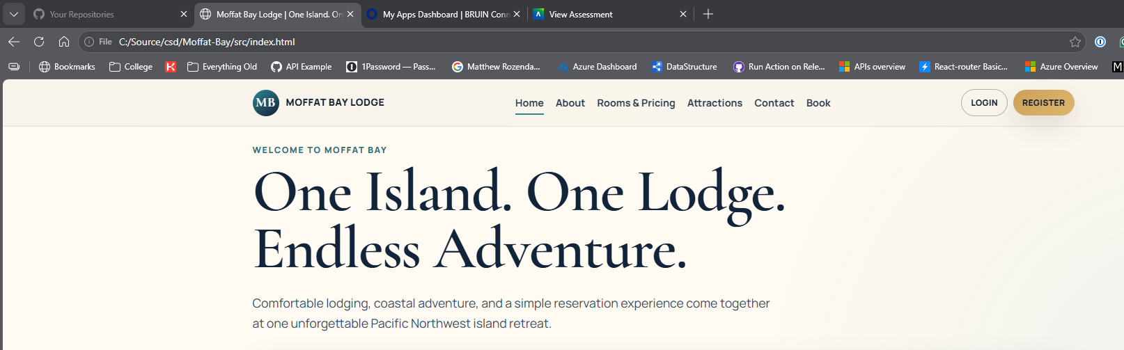 | Yes | Yes
2 | Click Register button | 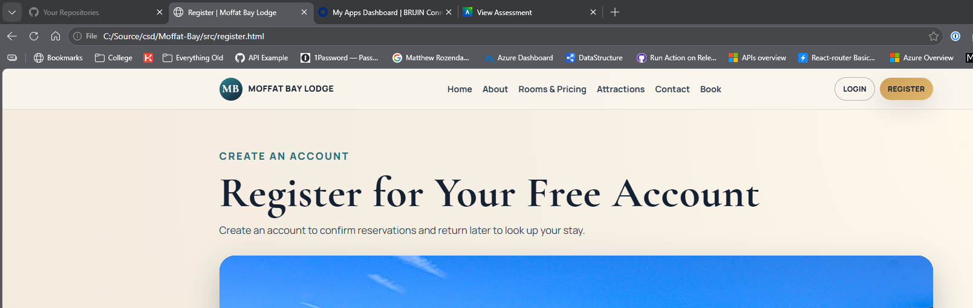 | Yes | Yes
3 | Scroll down to the register form | 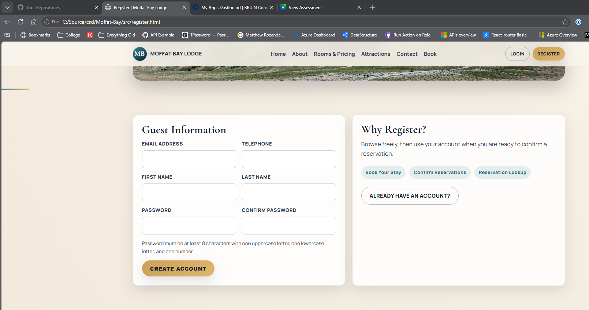 | Yes | Yes
4 | Verify you the form has inputs for Email, phone, Firstname, lastname, password, and password confirmation |  | Yes | Yes
5 | Verify that there is a blurb about password requirements | 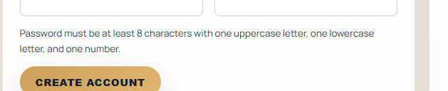 | Yes | Yes
Comments | The page loads correctly. The Form shows needed inputs

Test 2 | <DESCRIPTION>
 | Test Objective: | Developer: Matthew Rozendaal  Date tested: 2026/09/05 | Developer: Matthew Rozendaal  Date tested: 2026/09/05
Step | Action | Expected results: | Developer pass/fail | Tester pass/fail
1 | Go to Moffat-Bay.index html |  | Yes | Yes
2 | Click Register button |  | Yes | Yes
3 | Scroll down to the register form |  | Yes | Yes
4 | For Email Address Enter m@m.com |  | Yes | Yes
5 | For Telephone enter 123-456-7890 |  | Yes | Yes
6 | For Firstname enter: Test |  | Yes | Yes
7 | For last name enter: User |  | Yes | Yes
8 | For Password and confirmation enter: Test1234 | 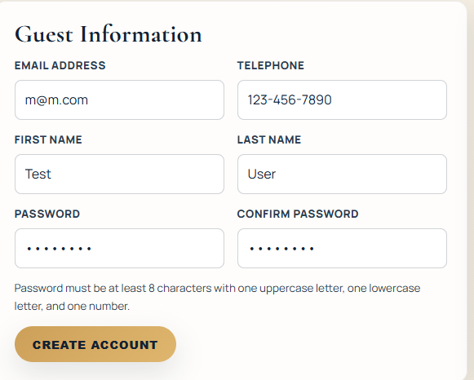 | Yes | Yes
9 | Click Create Account | You should see the users first name in the top right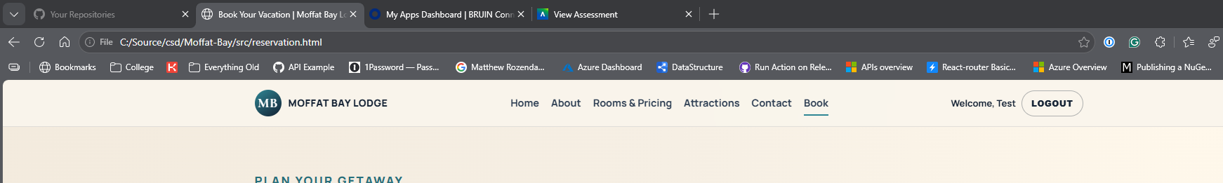 | Yes | Yes
Comments | These tests are missing some expected result examples.The final result still looks good though

